Oregon Department of Forestry Broadcast/Understory Burn Plan
Landowner Name and Address and/or Driving Directions to Unit |  |  | Township |  | Range |  | Section |  | County |  | Lat/Long (Degrees, Decimal Minutes) |  |  |  |  | Unit Name
Peter Ferré  74218 Troy Road  Wallowa, OR 97885 |  |  | 02N |  | 42E |  | 24 |  | Wallowa |  | N 45° 38.7983’  W 117° 30.6435’ |  |  |  |  | Ferré 2
SIGNATURES
Preparer(s): |  |  |  |  |  |  |  |  |  |  |  | Date:
Certified Burn Manager Name, CBM #, and Phone: |  |  | Jenny Reinheardt, CBM#20250820PB34, 541-910-0160 |  |  |  |  |  |  |  |  | Date:
Landowner(s): |  |  | Peter Ferré, 615-429-0502 |  |  |  |  |  |  |  |  | Date:
REGISTRATIONS, SMOKE CLEARANCE, AND PERMITS
NOAP and/or PDM Number and Smoke Registration (if required) |  |  | 2026-974-03261 |  |  | Burn and Smoke Permit Obtained (if required) |  |  |  | To be obtained
NOTIFICATIONS
NEARBY LANDOWNERS AND NEIGHBORS |  |  |  |  |  | FIRE, EMERGENCY RESPONSE, AND AIR QUALITY CONTACTS
Name |  |  | Contact Info |  |  | Name |  |  |  | Contact Info
See attached list |  |  |  |  |  | Oregon Department of Forestry Wallowa |  |  |  | 541-886-2881
 |  |  |  |  |  | Wallowa Rural Fire |  |  |  | 541-886-2422
 |  |  |  |  |  | Blue Mountain Interagency Dispatch Center |  |  |  | 541-963-7171
 |  |  |  |  |  | Local Air Quality (if applicable)

BURN UNIT DESCRIPTION
Fuel Type (Slash, Brush, Grass, and/or Timber) |  |  |  |  | Fuel Loading (tons/acre) |  |  |  |  |  |  |  | Size of Unit (acres)
Grass |  |  |  |  | <1 |  |  |  |  |  |  |  | Up to ~18
PRE-BURN FUELS AND VEGETATION DESCRIPTION INSIDE BURN UNIT:

Entire unit contains short grass <8” in height. Invasive annual grass (medusahead) will be primary carrier of fire. Fuel load is sparse, but heavier on soil mounds. A few mature ponderosa pine and western juniper in the unit, but very sparse.
Aspect is south and slope ranges from approximately 5-30%.

PRE-BURN FUELS AND VEGETATION DESCRIPTION OUTSIDE BURN UNIT:

Fuels west of unit on neighboring property are same as in unit – short grass. Area north of the unit is ponderosa pine with low shrub and grass understory and was recently burned in October 2025, resulting in low fuel loads. Area east of the unit contains short grass and includes some ponderosa pine forest with grass understory. A draw is present south of the unit and leads to a north facing slope with mixed conifer timber.

PRE-BURN PREPARATION
DESCRIPTION OF PRIMARY CONTROL LINES AND PREPARATIONS FOR USE:
All control lines will be a combination of wet line and black lining. North end of unit will be wet lined with engines or other equipment, while other control lines will be wet lined with UTV/ATV or bladder bags as fire progresses downslope.

LOCATION OF AND CONFIRMATION OF ACCESS TO PRIMARY WATER SOURCES:
Primary water source (excluding resources holding water) will be three garden hose spickets located approximately 1000 feet NE of north control line (see map)

MINIMUM RESOURCES - PERSONNEL
Number Needed |  | Position |  |  | Description
1 |  | Certified Burn Manager |  |  | Certified to lead broadcast/understory burns
1 |  | Holding Boss |  |  | Lead holding/containment operations
MINIMUM RESOURCES - EQUIPMENT
Number needed | Equipment Type |  |  |  |  |  |  |  |  |  |  |  | Burn Phase (Ignition and/or Patrol/Mop-Up)
RADIO, CELLULAR, OR OTHER FORMS OF COMMUNICATIONS
SYSTEM | FUNCTION | FREQUENCY |  | ASSIGNMENT
TX
RX
VHF | Command |  | Akers | Communication with dispatch and emergency notifications

CONTINGENCY AND WILDFIRE DECLARATION
CONTINGENCY ACTION POINTS INCLUDING WHEN AND HOW TO RESPOND:
Activate contingency if fire activity is exceeding holding capacity of on-site resources or if any spots or slopovers result in fire activity outside the burn unit that exceeds ½ acre or is not controlled within 20 minutes.

LOCATION AND CONDITION OF SECONDARY CONTROL LINES AND BACK-UP WATER SOURCES:
Nearest secondary control lines are the 2025 burn unit and adjacent road north of the unit and then Dry Creek north of there. Several ponds on the property are back-up water sources, but require an apparatus with the ability to draft water.

CRITERIA AND PROCEDURE FOR WILDFIRE DECLARATION:
Spot fires, slopovers, or other fire transmission across property boundary or fire behavior exceeding the capacity of on-site and contingency resources will require immediate notification of ODF and declaration of wildfire. If wildfire is declared, Rx fire ignitions will be ceased when it is safe to do so and any personnel not required for holding of Rx fire will attempt suppression of wildfire within their training and abilities. Incident command will be turned over to ODF as soon as they arrive on site. Rx burn manager will maintain control of the Rx fire.
Contingency Resource Name |  |  |  |  | Response Time |  |  |  |  | Location
Oregon Department of Forestry |  |  |  |  | ~20 minutes |  |  |  |  | Wallowa, OR
VALUES AT RISK AND PRESCRIPTIVE SIDEBOARDS INSIDE AND OUTSIDE UNIT
MITIGATION MEASURES TO PROTECT VALUES AT RISK:
The fenceline and adjacent properties to the west and south are the primary values at risk. Adequate holding resources will be put in place to avoid fire transmission onto neighboring properties.

SMOKE MANAGEMENT
Nearest Smoke Sensitive Receptor(s)/Class 1 Airshed |  |  | Enterprise |  |  |  |  | Distance and Direction |  | SE 19 miles
MITIGATION STRATEGIES AND TECHNIQUES TO REDUCE IMPACTS:
Burn will be implemented only if smoke forecast indicates adequate smoke lift and dissipation. If any large logs or stumps burn, mop them up as much as possible to reduce smoldering fire and lingering smoke.

SMOKE MANAGEMENT FORECAST DAY BEFORE/DAY OF BURN:
To be obtained

TEST FIRE AND IGNITIONS
TEST FIRE LOCATION(S):
Test fire will be conducted in an area with representative fuels and where the fire can be easily controlled. Test fire will likely be lit along the north control line, but that location will depend on wind direction.

IGNITION EQUIPMENT, METHODS, AND SEQUENCES:
Drip torches, propane burners, or other ignition devices will be used as needed. Sufficient blackline will be created along the downwind control line and proceed along the flanks of the unit. Once sufficient blackline is in place downwind, proceed with strip head fires through the interior of the unit and continue to blackline flanks as burn progresses. Ignitions should be focused on the mounds that contain more continuous fuels, and any large logs, stumps, or other debris should not be ignited. Alternative firing patterns, techniques, and ignition devices may be used at the discretion of the Certified Burn Manager and Firing Boss as needed.

HOLDING AND CONTAINMENT
CRITICAL HOLDING POINTS AND MITIGATIONS:
The most critical holding points are the property boundaries adjacent to the west and south. Ensure sufficient holding crews are in place to prevent transmission across property boundary.

CONTAINMENT LINE SPECIFICATIONS AND RATIONALE:
A combination of wet line and black line will be sufficient containment for the short flashy fuels in the unit. Ensure sufficient water is placed on wet line and ensure that wet line is holding after ignitions proceed along the line. Apply more water as needed.

MOP-UP, PATROL, AND NOTIFICATION OF DECLARING BURN OUT
MOP-UP STANDARDS:
Extinguish all flaming and smoldering fuels in the unit within 50 feet of the west and south control lines to minimize possibility of fire escaping onto neighboring properties. Extinguish all flaming and smoldering fuels within 25 feet of all other control lines.

FREQUENCY AND DURATION OF PATROL:
Patrol the burn unit twice (once in late morning, once in afternoon) the day following the burn. Unless active fire activity is observed, patrol once per day in the afternoon at the height of the burning period until burn is declared out.

DESCRIBE CRITERIA AND NOTIFICATIONS FOR DECLARING THE BURN OUT:
Burn can be declared out after three days of no fire detected or after significant precipitation on the burn site. Consult with ODF as needed to make informed decision.

SAFETY, MEDICAL, AND EMERGENCY PLAN
NEAREST HOSPITAL:
Wallowa Memorial Hospital, 601 Medical Pkwy, Enterprise, OR 97828

SAFETY ISSUES AND MITIGATIONS:
Any potential hazards (wasp nests, walking hazards, snags, etc.) near the burn unit should be identified and communicated to resources during burn briefing. Emergency protocols and locations of first aid kits will be communicated to all resources during burn briefing. Maintain LCES (lookout, communication, escape routes, safety zones). Recognize the black as a safety zone.

RALLY POINT INCLUDING DRIVING DIRECTIONS:
In case of emergency or need for evacuation, all resources should move in an orderly fashion to the large gravel area near the driveway entrance at 74218 Troy Road. Vehicles should drive directly down to Troy Road and then proceed south to the main driveway for the property.

RESOURCE MANAGEMENT GOALS
-Reduce invasive annual grass cover and thatch buildup in preparation for further site restoration (seeding, herbicide, etc.)
-Provide opportunities for training personnel on the burn whenever safe to do so
-Enhance/stimulate native and non-invasive grasses and forbs
-Enhance forage opportunities for wildlife

PRESCRIBED FIRE OBJECTIVES
-Burn at 40-90% of the unit
-Consume 50-95% of dead thatch grass

ENVIRONMENTAL PARAMETERS AND FIRE BEHAVIOR
ENVIRONMENTAL PRESCRIPTION |  |  |  |  |  |  |  | ACCEPTABLE FIRE BEHAVIOR
 |  |  |  | Low | High |  |  |  |  | Low |  |  |  | High
Temperature (°F) |  |  |  |  |  |  |  | Flame Length (ft) |  | 0.5
Relative Humidity (%) |  |  |  |  |  |  |  | Rate of Spread (ch/hr)
20-ft. Wind Speed (Forecasted)
20-ft. Wind Direction (Forecasted)
Eye-Level Wind Speed (Observed)
Eye-Level Wind Direction (Observed)
Transport Wind Direction |  |  |  | Any | Any
Fine Dead (1-Hr) Fuel Moisture
WEATHER MONITORING AND METHODS
MOST REPRESENTATIVE REMOTE AUTOMATED WEATHER STATION (RAWS) OR OTHER RELIABLE WEATHER STATION:
National Weather Service fire weather forecast and Roberts Butte RAWS, Eden RAWS, and Point Prom RAWS. Spot weather forecast to be obtained for day of the burn as long as approved by NWS. Daily on-site weather will be recorded the preceding two days before the burn and submitted with spot weather forecast. Verify general forecast with spot forecast. Report weather readings back to National Weather Service forecasters following the burn.

WEATHER DATA COLLECTION METHOD AND FREQUENCY BEFORE, DURING, AND AFTER IGNITIONS:
On-site weather will be collected using a kestrel or belt weather kit prior to ignitions and during the burn at the discretion of the burn manager, likely at 30-minute or 1-hour intervals. Weather observations will be communicated to burn manager, firing boss, and holding boss. After the burn, weather conditions will be monitored using National Weather Service fire weather forecast until burn is declared out.

POST-BURN FUELS AND VEGETATION MONITORING AND METHODS

DESCRIBE METHODS FOR MONITORING POST-FIRE EFFECTS:
Visual estimates of percent of unit burned directly following burn.
Other monitoring methods may be used as needed for educational purposes or at the request of the landowner.

ATTACHMENT A – VICINITY AND BURN UNIT MAPS
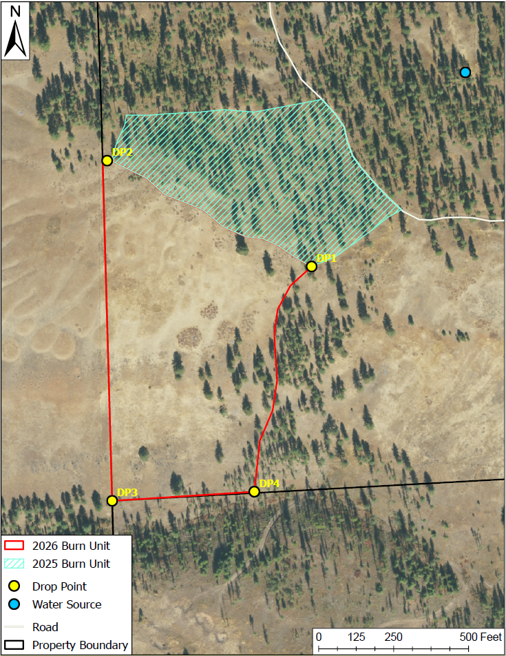

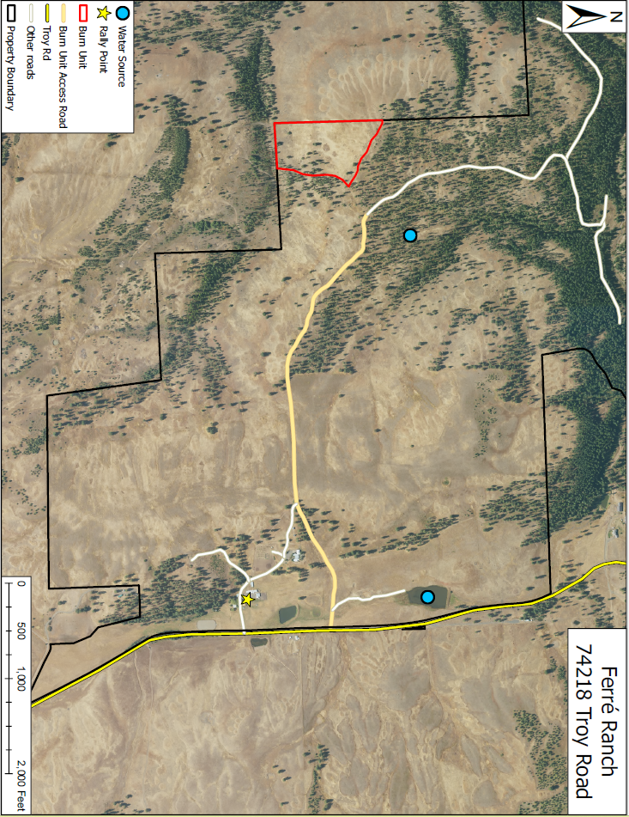

ATTACHMENT B – PRE AND POST-BURN CHECKLIST

- PRE-BURN (Prior to Crew Briefing)

Fire Unit is as described in plan and copy of plan is on site.
Required firebreaks complete and are consistent with current and predicted conditions.
Certified Burn Manager assigned, permits obtained and documented in burn plan.
Required number of personnel present.
Short and long-range weather and smoke management forecast obtained and within prescription.
Notifications complete.
Required equipment for holding, weather monitoring, ignition, and suppression on-site and functioning.
Personnel have reviewed equipment for readiness.
Planned ignition, holding, and containment methods are appropriate for current and predicted conditions.
Planned contingencies, mop-up, and patrol are appropriate for current and predicted conditions.
Off-site contingency resources are operational and available.

- CREW BRIEFING

Burn unit size, boundaries, and fuels inside and outside unit reviewed with maps provided for reference.
Hazards and safety issues.
Prescribed burn objectives
Anticipated fire and smoke behavior.
Organization of crew and assignments.
Methods of ignition, holding, mop-up, communications.
Contact with the public, traffic concerns.
Location of main roads, vehicles, keys, and nearest phone.
Location of back-up equipment, supplies, and water.
Suppression plan and use of contingency resources for escaped prescribed fire.
Medical emergency procedures
Answer questions from crew.

- TEST FIRE

On-site weather and fuel conditions are within prescription and consistent with forecast.
Test burn conducted, fire and smoke behavior within prescribed parameters.

D. POST BURN CHECKLIST

Mop-up completed to standards as described in burn plan.
Night patrol assigned, if needed.
Personnel and equipment assigned for days following burn, if needed.
Notifications of completed burn, if required.
Debrief or After-Action Review (AAR)

Certified Burn Manager sign and date form when burn is completed and has been turned over to the landowner or another Certified Burn Manager.

Certified Burn Manager Signature: ___________ Date: __________________

ATTACHMENT C – ADJACENT LANDOWNERS NOTIFIED

Name | Contact | Address | City, State | Zip
Nancy McCrae Trust |  | 1547 Vale View Rd | Vale, OR | 97918
Manulife Investment Management | Joe Justice,  Region Manager | 1919 Jackson Ave | La Grande, OR | 97850
SJS Ranch, LLC |  | 10 Windover Rd | Greenwood Village, CO | 80121
McCrae Revocable Trust et al |  | 304 Riverside Ave | Wallowa, OR | 97885
Nyoda Scott | Kim Sines | 10303 S Grande View Dr | La Grande, OR | 97850
7-T Ranch, LLC |  | 12303 Fishermans Way | Oregon City, OR | 97045
John Nickels II |  | 75288 Troy Rod | Wallowa, OR | 97885
Dennis Waldron |  | 21200 Sandlake Rd | Cloverdale, OR | 97112
Brown-Risley Family Trust |  | 17200 Sullivan Ln | Newber, OR | 97132
Davis Canyon Ranch, LLC |  | 200 E Main St | Enterprise, OR | 97828

ATTACHMENT C – CBM TRANSFER OF RESPONSIBILITY FORM

OREGON DEPARTMENT OF FORESTRY

CERTIFIED BURN MANAGER PRESCRIBED FIRE TRANSFER OF RESPONSIBILITY
Pursuant to OAR 629-042-1040 to 1055 when a prescribed fire has achieved the conditions documented in the prescribed burn plan and the Certified Burn Manager (CBM) is no longer required to be on site of a prescribed fire, the CBM hereby transfers responsibility to the
person/company below under the following conditions.
- Transfer conditions as outlined in OAR629-042-1045 2(a) have been met.
- The Oregon Department of Forestry District has been notified of the transfer of responsibility.

The landowner or CBM assumes responsibility of control and mop up as outlined in the burn plan.
The (identifier) prescribed fire located at
TRSQ or Lat/Long under notification number (if NOAP) is hereby transferred from (CBM) to
(person or company) effective AM/PM on
, 20 .

Landowner/CBM

Certified Burn Manager

WARNING: A failure to provide the personnel and equipment under your supervision and control which are in the judgment of the forester needed and effective to fight fire, and which are reasonably available, and which can be brought to bear on the fire in a timely fashion may subject you to liability to the state for all of the costs of controlling and extinguishing the fire.

